Software Requirements Specification (SRS)

Lane Management System

**Authors: Ian Berriel, Ben Gibbons, Zack Joyce, Tyson Lance, Michael Monticciolo**

Customer: Ayush Agrawal

Instructor: Dr. Betty Cheng

1. **Introduction**

While the automotive industry is not fully autonomous at this time, many vehicles are adding in partially autonomous systems to aid the driver in their commutes. One such system is the Lane Management System (LMS). The LMS is a suite of sensors, cameras, and software that is capable of warning a driver when they are exiting their lane and adjusting the vehicle’s path to prevent exiting the lane. The LMS can be broken down into three primary components that work in tandem: the Lane Departure Warning System (LDWS), the Lane Keeping System (LKS), and the Lane Centering System (LCS). Each of these subsystems covers one section of the LMS’s functionality. This document describes the LMS system in a behavioral and structural manner. Models and prototypes are utilized to ensure a visual understanding; while text is supplemented for additional information.

* 1. **Purpose**

The purpose of this Software Requirement Specification (SRS) document is to provide a comprehensive overview of the LMS system. That overview will entail: the software requirements, the assumptions and constraints of the project, the high level functionality of the system, and an interactive prototype to demonstrate the intended functionality of the LMS. These resources are intended to provide an easy to understand breakdown of the LMS to stakeholders to ensure that the current requirements and functionality match the initial vision for the system. In the event of a consensus of approval being reached by the stakeholders, this document will serve as a guide for developers when creating the LMS and implementing the hardware it requires.

* 1. **Scope**

The LMS is the primary product to be delivered from this project. This can be broken down into the LDWS, the LKS, and the LCS. As a whole, these systems are referred to as the LMS. The purpose of the LMS is to provide a semi-autonomous driving experience to the driver. The system has two states: off and on. The off state refers to the LMS’s deactivated state. In this state, the LMS will not correct the vehicle’s trajectory or alert the driver when they are exiting the lane. In the on state, the LMS will correct the trajectory of the vehicle and warn the driver. In ideal conditions, the driver will be able to focus on traffic surrounding them and large scale changes in direction while the LMS is active. It will prevent any drifting while inside a lane. This product will in no way prevent or assist with frontal collisions or rear-ending collisions. The product is capable of adjusting the speed of the vehicle if necessary; however, this feature is only intended to be used to keep the vehicle in its lane. The LMS will return control of the vehicle to the driver in the event of ambiguity in its calculations. This varies from sensor fault to lack of lane lines. This system falls under the embedded automotive system umbrella.

* 1. **Definitions, acronyms, and abbreviations**
* **LMS**: Lane Management System: The LMS is the overarching product and system. It contains the other subsystems.
* **LDWS:** Lane Departure Warning System: The LDWS is the element of the system that notifies the Lane Keeping System that an adjustment must be made. It is also the element of the LMS that will notify the driver that they are exiting a lane unintentionally.
* **LKS:** Lane Keeping System: This system addresses the signals sent out by the LDWS and passes the information on to the Lane Centering System.
* **LCS:** Lane Centering System; This system adjusts the car’s steering trajectory to keep it in the lane.
* **Lane Exiting Signal:** A signal produced by the Path Prediction Subsystem indicating that the vehicle will need corrective measures to stay in the lane
* **ECU:** Electronic Control Unit: An ECU is a small device responsible for controlling a section or subsystem of a vehicle.
  1. **Organization**

The first section provides an introduction to the project and some preliminary information on the LMS including scope, vocabulary breakdown, and purpose. The second section introduces constraints and expectations surrounding the project and its development. Section 3 contains an enumerated list of the LMS’s requirements as well as its potential cybersecurity risks. The visual portion of this document is contained in Sections 4 and 5. These sections contain the use case diagram, domain model, and the interactive prototype for the LMS. Finally, Section 6 and 7 provide references and further points of contact respectively.

1. **Overall Description**

Section 2 contains technical descriptions of the product’s attributes. Section 2.1 will describe the product context, explaining why the system is being developed and how it will interact with the rest of the vehicle. Section 2.2 describes the major functions the software will perform using vocabulary that can be easily comprehended by any reader. Section 2.3 will outline user expectations which can range from safe system operation to driving ability. 2.4 will describe specific product constraints while section 2.5 is designated for critical assumptions and dependencies. 2.6 will annotate mentioned requirements that are determined to be of lower priority/out of scope of the system.

* 1. **Product Perspective**

The LMS is an enhanced, semi-automated safety feature implemented in new vehicles to help drivers maintain centrality in a designated lane. This feature is being designed with the intention of giving the vehicle some autonomy with an operator option to abort at any moment. The operator's ability to enable/disable the system is important to note in case of an emergency, so the vehicle isn’t limited to a predetermined set of instructions. This semi-autonomy should allow the operator to feel relaxed over the course of a long road-trip, but is also designed with the ability to be disabled in the event where a sharp change of direction may be needed.

The LMS will not be available until the vehicle meets a velocity requirement of 35 miles per hour. Upon meeting this requirement, the driver will have the option to activate this feature using a physical button located on the left connector of the steering wheel. When the system is toggled on, the LMS will keep the car in the middle of the lane and the indicator light located under the speedometer will turn on. If the car happens to approach the edge of the lane, an alarm will activate in the form of a high pitched bell sound. In the event the driver chooses to switch lanes, activating the turn signal will temporarily disable the alarm. (Still working on this)

* 1. **Product Functions**

The LMS keeps the operating vehicle in the middle of the lane using a series of sensors lined along the outside of the vehicle. The LMS has three major subsystems that communicate with each other to maintain the vehicle’s centering. The LDWS interprets information from external sensors and communicates the car’s position with the LKS. The LDWS is critical because of its role in interpreting the data from the hardware into values that the system can use to eventually guide the vehicle. The LKS is in charge of interpreting the signals received from the LDWS and communicating with the LCS. For example, after receiving values from the LDWS, the LKS then makes a decision as to if the vehicle needs to be redirected, and in which direction. The LCS then adjusts the vehicle using information from the LKS. After the information gathered from the external sensors has been processed, the LCS then applies the changes necessary to keep the vehicle centered. The LCS will normally adjust the steering wheel position and acceleration under normal conditions.

* 1. **User Characteristics**

The user operating this system should possess a driver’s license or equivalent in the region where the vehicle is approved for sale and operation. It is recommended that the user also follow traffic laws in accordance with local regulations. With LMS activated, the user should remain attentive to their driving, but should also expect assistance in situations where the vehicle may drift. In addition, LMS will offer correcting of the vehicle trajectory when the operator approaches a line and must be recentered.

* 1. **Constraints**

In order to guarantee the highest safety possible while using the LMS, the system will only be active when it has a very high confidence that it could avoid situations (full trust that the system will work as expected). High confidence refers to the LMS having all the data it desires including lane marker positioning, vehicle speed, and vehicle steering angle. If an ideal condition is met, like a perfect road, LMS will be active in its confidence, while LMS will not be confident on weathered roads or conditions. When there are events, such as missing lane markings, dangerous road conditions (snow, rain, sleet, hail, etc.), or other unforeseen circumstances, LMS will alert the user that it is not active and cannot assist if needed. In the event that any sensors or systems become inadequate for protecting the driver, the system will alert the driver and deactivate in order to prevent causing more dangerous situations. Such situations could include car related mechanical issues, sensors becoming unreachable or unusable, or failure in confidence that the system can maintain a lane.

* 1. **Assumptions and Dependencies**

For the development of the LMS the vehicle is assumed to be outfitted with a number of subsystems and instruments. It is expected that the vehicles will be equipped with power steering, braking, and acceleration. In order for the LMS to properly take in its surroundings, it is assumed that the vehicle will have a full suite of cameras and sensors as well as software capable of processing the information these peripherals provide. A full suite refers to at minimum two cameras mounted on the side mirrors capable of viewing roadlines in all lighting conditions. It is also assumed that the LMS will be provided with the state the vehicle is in. This meaning the LMS will receive the speed, steering angle, and road curvature from the vehicle. It is also assumed that a path will be predicted by the Path Prediction Subsystem and sent to the LMS.

* 1. **Approportioning of Requirements**

The system will have hardware decisions made as finalized decisions, but there will be continual updates of the software via an over-the-air update system. All new features will be determined with the demands that arise after LMS has been deployed, however, LMS will function through its subsystems in order to maintain a lane from launch. At a later time the LMS will be connected to a worldwide GPS system that enables it to have an alternate source of data as to how wide a lane is. If it is found to be necessary, LMS will also use data provided from vehicles in order to train and improve, thus allowing for all vehicles with LMS to further improve in the future. LMS will also potentially receive updates, such as the ability to implement level two self-driving, by adding radar based cruise control. Another feature that may be implemented at a future date is using the data processed by the LMS to avoid sideswipes.

1. **Specific Requirements**

The requirements for the system are as follows:

1. The LMS will have access to predefined subsystems that will provide data and enable the LMS to carry out its functionality. These subsystems are **not** created, defined, or managed by LMS or its requirements.
   1. The Path Prediction Subsystem will provide the LMS with information regarding the path and state of the vehicle. It is a predefined system the LMS will make use of.
      1. The Path Prediction Subsystem will analyze the trajectory of the vehicle and report to the LMS if the course needs to be corrected.
   2. The User Interface system will serve as the communicator between the LMS and the driver. It is a predefined system that the LMS will make use of.
      1. The LMS will be able to indicate to the driver its state and any warnings it produces through this system.
      2. This system will give the LMS access to the dashboard/instrument panel as well as the audio system of the vehicle.
   3. The Camera Sensing Subsystem will be a network of sensors (UV and standard cameras) that feed their information into the Path Prediction Subsystem.
      1. The LMS will not interact with the Camera Sensing Subsystem, but its data is an absolute necessity in the functionality of the LMS. Without this subsystem, the LMS cannot find the roadlines.
   4. The LMS will make use of a separate system for its calculations for the Path Prediction subsystem and Image Processing subsystem to ensure the ECU does not become overwhelmed.

2. The LMS will have a button to turn on or off functioning through the User Interface system.

2.1. The button will be mounted on the left spoke of the steering wheel to provide easy access for the driver.

3. The LMS will express that it is on via the User Interface system activating a light indicator on the dash display While the LMS is active a light will be lit on the dash display

3.1. The light indicator will be located underneath the speedometer or equivalent instrument in the gauge cluster

3.2. The light will be green in color when the LMS is active and off when the LMS is deactivated.

3.3. In the event of the LMS being unable to function due to ambiguity or otherwise, the light indicator will be red.

4. The LMS will receive a Lane Exiting signal that is produced by the Path Prediction Subsystem.

4.1. The Lane Exiting signal shall indicate to the LMS that the vehicle is on a path that will exit the current lane

4.2. An Lane Exiting signal will be produced when the path of the vehicle will deviate from the lane within 3 seconds of driving.

4.2.1. Deviating from the lane consists of angling the vehicle in such a manner that the current path will intersect with the road lines detected by the Image Processing Subsystem.

4.3. The Lane Exiting signal will be ignored if the vehicle’s blinker is on.

4.4. The LMS will only activate when the vehicle’s speed is in excess of 35 miles per hour.

5. The LMS will sound an alarm and flash a warning via the User Interface system in the event of a Lane Exiting Signal (3)

5.1. The signal will only be sent if the Lane Exiting signal is constant for 2 seconds.

5.1.1. The alarm will be a higher pitched bell frequency

5.3. The warning pop-up will constantly be shown on the dash display and the alarm will sound every 3 seconds until the Lane Exiting signal stopped

6. The LMS will pause the LKS and the LDWS itself in the event of no road lines being found by the Camera Sensing Subsystem or the Path Prediction subsystem being unable to predict a path.

6.1. The Driver will be prompted via the User Interface subsystem

6.1.1. A notification will appear on the dash display stating the LMS is paused

6.1.2. A bell sound will be made distinct from the sound found in (4)

7. The LMS will be connected to the vehicle’s built in steering system in order to allow LKS to adjust the trajectory of the vehicle.

7.1. The LCS will be capable of applying torque to the steering wheel

7.1.1 The LCS will be limited to 5 Nm of torque. [3]

7.2. The LCS will receive data from the LKS on how much force to apply to the steering wheel, and when to start or stop adjusting the vehicle’s trajectory.

7.3. The LKS will determine when and how to steer the vehicle based on the Path Prediction System.

8. LMS will toggle off for 5 seconds in the event of a blinker being pulsed or for the duration of the signal.

8.1. LMS will not toggle back on if a lane lines cannot be found

8.2. LMS will not toggle back on if the Path Prediction subsystem cannot generate a path to predict the vehicle.

Cyber Security Requirements are as follows:

1. The LMS and its subsystems will be processed on a separate ECU to prevent manipulation from an external source.
2. The LCS will not be able to apply more than 5 Nm of Torque to prevent jagged changes. Even if the system becomes compromised, the LCS can only slowly adjust vehicle trajectory.

1. **Modeling Requirements**

This section outlines the LMS as well as the other major systems working in the vehicle such as the LDWS, LKS, and LCS. This includes the Use Case Diagram and Sequence Diagrams.

**4.1 Use Case Diagram**

Figure 1 shows the Use Case Diagram for all the major uses in our System and their relationships with each other. The actors included are the UI System, GPS System, Image Processing System, Vehicle State Estimation System, Driver, Braking System, and Steering System. The use cases are the User Toggle System, the Lane Exiting Signal, the UV Sensors, the LCS, the LKS, and the LDWS.

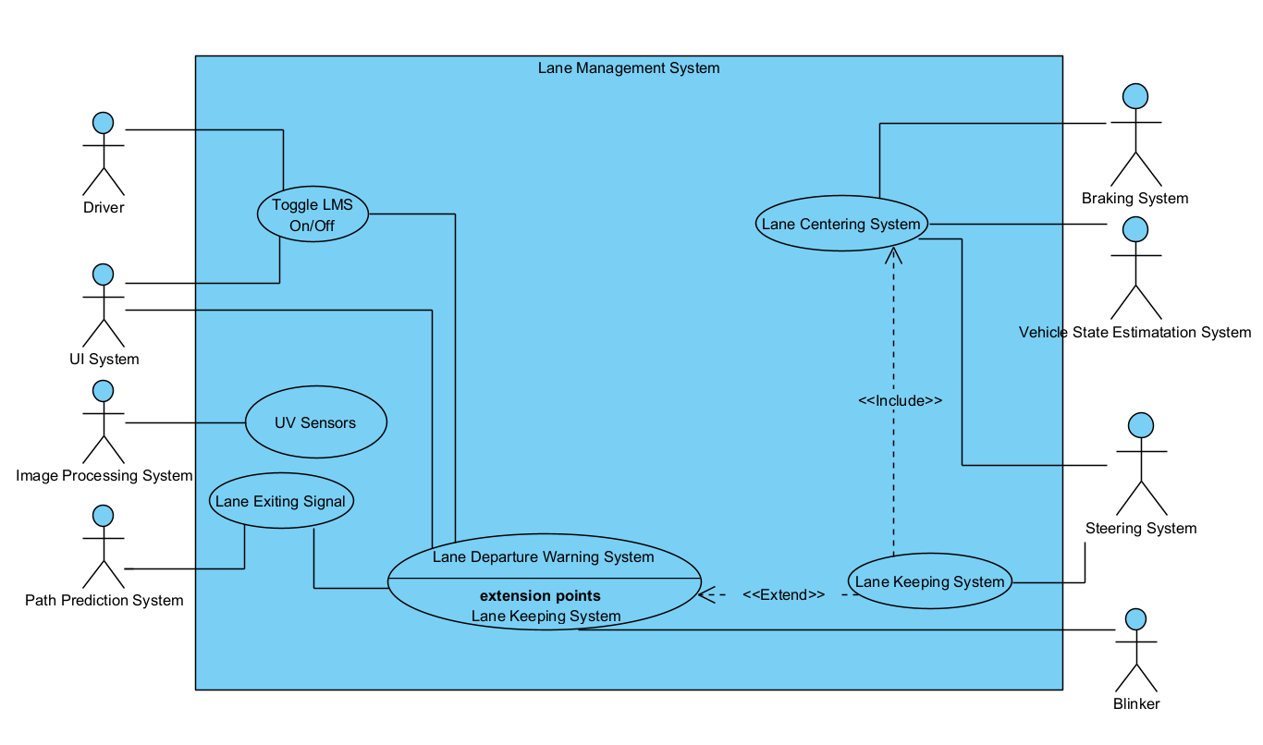

Figure 1. Use Case Diagram

Table 1. Use Cases

| Use Case | *Lane Exiting Signal* |
| --- | --- |
| Actors | *Path Prediction System* |
| Description | *This alerts the LMS that the vehicle is currently projected to leave the lane at the current path it is on.* |
| Type | *Primary* |
| Includes | *NA* |
| Extends | *NA* |
| Cross-refs | *Requirements 4.1, 4.2, 4.2.1,4.3, 4.4, 5.3* |
| Use Cases | *Lane Departure Warning System* |

| Use Case | *UV Sensors* |
| --- | --- |
| Actors | *Image Processing System* |
| Description | *These cameras are meant as an addition to the LMS in order to provide support at night. Data from these sensors is sent to the Image Processing System.* |
| Type | *Secondary* |
| Includes | *NA* |
| Extends | *NA* |
| Cross-refs | *Requirements 1.3* |
| Use cases | *NA* |

| Use Case | *Toggle LMS On/Off* |
| --- | --- |
| Actors | *UI System, Driver* |
| Description | *The user has the ability to turn off and on the LMS at any time. This button is mounted on the steering wheel for easy access. When the LMS is toggled on or off, the UI System will notify the driver of its state. A green steering wheel icon will be displayed when LMS is toggled on. The light will be off when the LMS is toggled off, and the light will be red in the event of the LMS being unable to function.* |
| Type | *Secondary* |
| Includes | *NA* |
| Extends | *NA* |
| Cross-refs | *Requirements 2, 3* |
| Use cases | *LDWS* |

| Use Case | *Lane Departure Warning System (LDWS)* |
| --- | --- |
| Actors | *Blinker, Vehicle State Estimation System* |
| Description | *The LDWS is the primary feature of the LMS. It receives a notification from the Lane Exiting Signal to be activated. From this signal it will notify the LKS if toggled on. If the LKS is not enabled, it will interact with the UI system to notify the driver. The LDWS also takes input from the blinker. If the blinker is active, no warning will be passed to the UI System, or the LKS will not be engaged.* |
| Type | *Primary* |
| Includes | *NA* |
| Extends | *NA* |
| Cross-refs | *Requirement 5, 6, 8* |
| Use cases | *Toggle LMS On/Off, UV Sensors, Lane Exiting Signal* |

| Use Case | *Lane Centering System* |
| --- | --- |
| Actors | *Braking System, Steering System* |
| Description | *The LCS is used to make sure that the vehicle is driving in the center of the lane rather than on the sides. Communicates with the Vehicle State Estimation System to get the current state of the vehicle (steering angle, speed, and road curvature). LCS makes an adjustment to the vehicle based on this data.* |
| Type | *Secondary* |
| Includes | *NA* |
| Extends | *NA* |
| Cross-refs | *Requirements: 7.1,7.2* |
| Use cases | *Lane Keeping System, Vehicle State Estimation System* |

| Use Case | *Lane Keeping System* |
| --- | --- |
| Actors | *Steering System* |
| Description | *This system addresses the signals sent out by the LDWS and passes the information on to the Lane Centering System.* |
| Type | *Secondary* |
| Includes | *Lane Centering System* |
| Extends | *Lane Departure Warning System* |
| Cross-refs | *Requirements: 4.4, 6,7* |
| Use cases | *NA* |

**4.2 Domain Model**

The domain model is introduced in this section below. The domain model holds all of the classes in the system, and shows how they are inherited from and interact with each other. For example, the Path Prediction System is a subsystem of the Lane Departure Warning System, Lane Keeping System, and Lane Centering System. This is shown on the model with generalizations from those three subsystems.

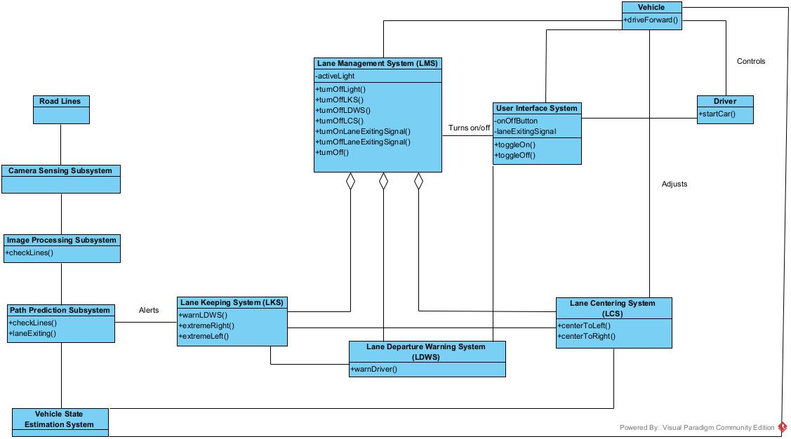

Figure 2: Domain Model for LMS

| **Element Name** | | **Description** | |
| --- | --- | --- | --- |
| Camera Sensing Subsystem |  | The camera sensing subsystem has the suite of cameras on the outside of the vehicle. Its job is to take pictures of the road and send them to the image processing subsystem. | |
| Attributes |  |  | |
| Operations |  |  | |
| Relationships | Road Lines, Image Processing Subsystem | | |
| UML Extensions |  | | |

| **Element Name** | | **Description** | |
| --- | --- | --- | --- |
| Driver |  | The driver controls the car throughout the drive. The driver is also capable of turning On/Off the LMS via the User Interface System. | |
| Attributes |  |  | |
| Operations |  |  | |
|  | startCar() |  | |
| Relationships | Vehicle, User Interface System | | |
| UML Extensions |  | | |

| **Element Name** | | **Description** | |
| --- | --- | --- | --- |
| Image Processing Subsystem |  | The image processing subsystem is in charge of processing the images passed into it from the camera sensing subsystem and identifying the lane markers. | |
| Attributes |  |  | |
| Operations | checkLines() | Determines where the car is in relation to the road lines. | |
|  |  |  | |
| Relationships | Image Processing Subsystem, Vehicle State Estimation System | | |
| UML Extensions |  | | |

| **Element Name** | | **Description** | |
| --- | --- | --- | --- |
| LCS |  | The LCS is in charge of centering the car when it is approaching the road lines. The LKS alerts the LCS, followed by the LCS adjusting the car. | |
| Attributes |  |  | |
| Operations |  |  | |
|  | centerToLeft() | Centers out the car by moving it to the left. | |
|  | centerToRight() | Centers out the car by moving it to the right. | |
| Relationships | User Interface System, Supervisory Control System, LKS, Vehicle | | |
| UML Extensions |  | | |

| **Element Name** | | **Description** | |
| --- | --- | --- | --- |
| LDWS |  | The LDWS is in charge of alerting the driver when they are on a course that will take them out of the lane. | |
| Attributes |  |  | |
| Operations |  |  | |
|  | warnDriver() | Warns the driver that they are on a path that will cause them to exit the lane if they do not correct. | |
| Relationships | LKS, LMS, User Interface System, Lane Centering System | | |
| UML Extensions | LKS | | |

| **Element Name** | | **Description** | |
| --- | --- | --- | --- |
| LKS |  | The LKS gets information from the path prediction subsystem and alerts other systems about the path of the vehicle. | |
| Attributes |  |  | |
| Operations |  |  | |
|  | warnLDWS() | Warns the LDWS that the driver is going out of the lane. | |
|  | extremeRight() | Tells the LCS that the car is on the right side of the lane and that it needs to recenter. | |
|  | extremeLeft() | Tells the LCS that the car is on the left side of the lane and that it needs to recenter. | |
| Relationships | Path Prediction Subsystem, LMS, LDWS, LCS | | |
| UML Extensions |  | | |

| **Element Name** | | **Description** | |
| --- | --- | --- | --- |
| LMS |  | The overhanging system in charge of all of the other subsystems. | |
| Attributes |  |  | |
|  | activeLight | Light representing if the LMS is active or not. | |
| Operations |  |  | |
|  | turnOffLight() | Turns off the light that shows if the LMS is on or not. | |
|  | turnOffLKS() | Turns off the LKS. | |
|  | turnOffLDWS() | Turns off the LDWS. | |
|  | turnOffLCS() | Turns off the LCS. | |
|  | turnOff() | Turns itself off. | |
|  | turnOnLaneExitingSignal() | Turns on the Lane Exiting Signal. | |
|  | turnOffLaneExitingSignal() | Turns off the Lane Exiting Signal. | |
| Relationships | Vehicle, User Interface System, LKS, LDWS, LCS | | |
| UML Extensions |  | | |

| **Element Name** | | **Description** | |
| --- | --- | --- | --- |
| Path Prediction Subsystem |  | Calculates the projected path of the vehicle and passes the info to the LKS. | |
| Attributes |  |  | |
| Operations | checkLines() | Scans the road lines and checks to see if the vehicle is close to the lines. | |
|  | laneExisting() | If road lines are not present or visible, this will alert the LKS and then turn off the LMS. | |
|  |  |  | |
| Relationships | Image Processing Subsystem, LKS, Vehicle State Estimation System | | |
| UML Extensions |  | | |

| **Element Name** | | **Description** | |
| --- | --- | --- | --- |
| Road Lines |  | The road lines are used by the Path Prediction Subsystem to determine if the vehicle is in the center of the lane. | |
| Attributes |  |  | |
| Operations |  |  | |
| Relationships | Camera Sensing Subsystem | | |
| UML Extensions |  | | |

| **Element Name** | | **Description** | |
| --- | --- | --- | --- |
| User Interface System |  | The driver and LMS exchange control and data through this system. | |
| Attributes | onOffButton | Turns On/Off the LMS. | |
|  | laneExitingSignal | Signal that alerts the driver when they are on a path that will take them out of the lane. | |
| Operations |  |  | |
|  | toggleOn() | Turns on the LMS. | |
|  | toggleOff() | Turns off the LMS. | |
| Relationships | LMS, Vehicle, Driver, LDWS | | |
| UML Extensions |  | | |

| **Element Name** | | **Description** | |
| --- | --- | --- | --- |
| Vehicle |  | This is the vehicle that the system is installed in. | |
| Attributes |  |  | |
|  | speed: Int | The speed of the vehicle in miles per hour. | |
| Operations |  |  | |
|  | driveForward() | Moves the vehicle forward on the road. | |
| Relationships | LMS, User Interface System, Driver, Vehicle State Estimation System | | |
| UML Extensions |  | | |

| **Element Name** | | **Description** | |
| --- | --- | --- | --- |
| Vehicle State Estimation System |  | The Vehicle State Estimation System is a set of sensors that determine the speed, steering angle, and road curvature. | |
| Attributes |  |  | |
| Operations |  |  | |
| Relationships | Path Prediction Subsystem, Vehicle | | |
| UML Extensions |  | | |

**4.3 Sequence Diagrams**

This section introduces how the sequence diagrams for the LMS.It shows how different systems and features within the vehicle function with each other during different events the user has when operating the vehicle.The boxes at the top of the diagram represent the objects in the scenario. The dotted lines below the boxes are the object lifelines. The lines with arrows between the lifelines are the messages. Those are used to connect objects together and show how they react with each other at different points during use.

**4.3.1 Turning on the System**

The figure below shows how the LMS functions from the beginning when the user turns on the car, up until the driver reaches the LMS threshold of 35mph. Until they reach that speed, the LMS will not turn on. Once they reach that speed, the LMS will activate. The user also has the option to press the button to turn the LMS off.

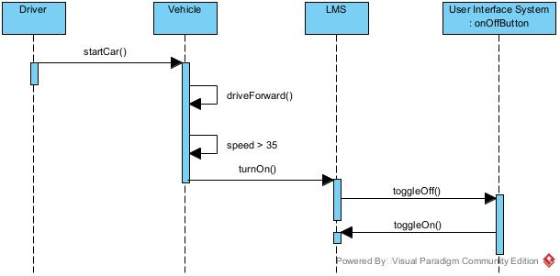Figure 4: Sequence Diagram for Turning On/Off LMS

**4.3.2 LKS Taking Over Control**

Figure 5 depicts what happens when the vehicle starts to approach either side of the road lines and the LKS needs to take over to straighten out the vehicle. Assuming the LMS is on, when the vehicle approaches the road lines, the LMS is alerted which sets off the other events. This causes the Lane Exit Signal to turn on, and then the LCS will start to correct the vehicle’s path.

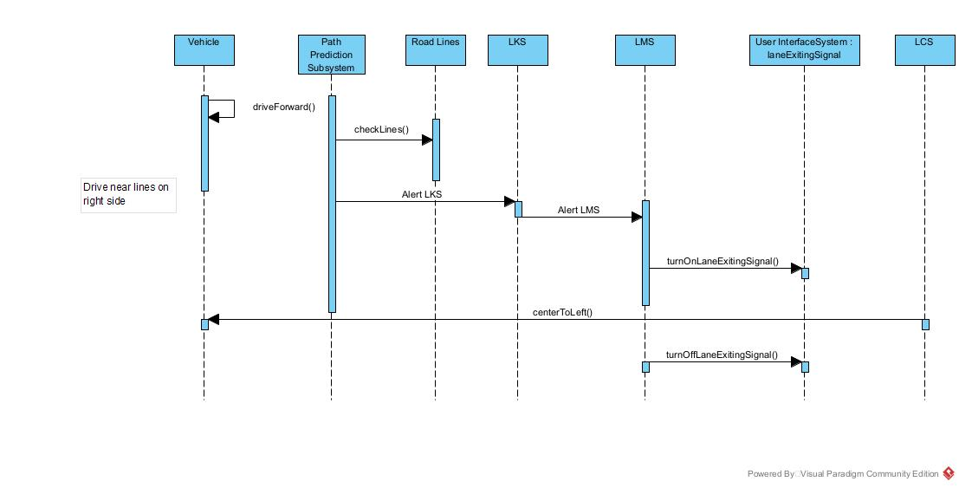Figure 5: Sequence Diagram for Adjusting Drifting Vehicle

**4.3.3 No Visible Road Lines**

Figure 6 demonstrates how the LMS functions when there are no road lines visible to the Camera Sensing System. When the vehicle cannot find road lines to use to keep the vehicle centered in the lane, it will alert the LMS. Then, the LMS turns off the light that shows LMS is active, and turns off the LKS and LDWS subsystems. It then turns itself off, and waits until the road lines become visible again.

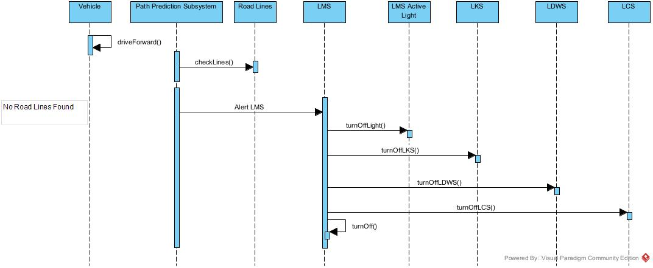

Figure 6: Sequence Diagram for Non-Visible Road Lines

**4.4 State Diagrams**

This section introduces the State Diagrams that are used for the LMS. It encompasses the LMS as a whole, as well as multiple subsystems and features. The State Diagrams represent different states or conditions that the systems or components can take on, and show the actions that must occur in order to switch between the states. The blue boxes are the states, and the lines between the states show how they change from one state to another.

**4.4.1 Lane Management System (LMS)**

Figure 7 depicts the Lane Management System which is the lead system in making sure the vehicle stays in the lane when operating under valid conditions. There are two ways to turn on the LMS. One is by driving the vehicle faster than 35 MPH, at which point it will activate. The user can also turn off the LMS by pressing the On/Off button. The user can turn the LMS back on at any time, assuming they are driving faster than 35 MPH.

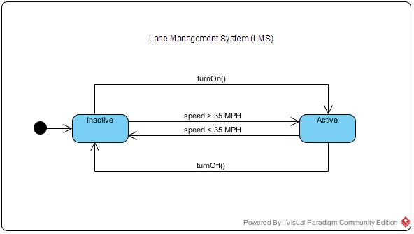Figure 7: State Diagram for Lane Management System

**4.4.2 Lane Exiting Signal**

Figure 8 shows how the Lane Exiting Signal is turned on and off. The lane exiting signal is a light that turns on when the user is on a path that will leave the road lines, assuming that their blinker is not on. If the blinker is on when traveling sideways, then the light will not turn on.

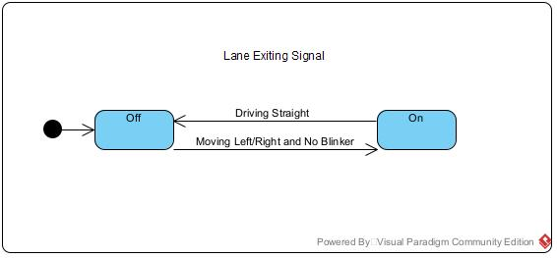Figure 8: Lane Exiting Signal

**4.4.3 Lane Departure Warning System (LDWS)**

Figure 9 depicts the Lane Departure Warning System. The LDWS is a subsystem of the LMS that validates the user is not traveling outside of the road lines. If the LMS is on, then so is the LDWS. The only time the LDWS turns off is when the LMS turns off.

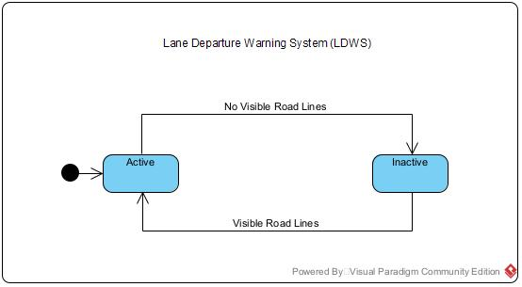Figure 9: Lane Departure Warning System

1. **Prototype**

The prototype associated with this project demonstrates the LMS’s ability to

correct a vehicle’s trajectory while moving as well as what is required before making corrections. It showcases the activation of the LMS, the throwing of the Lane Departure warning, and the steering override done by the LCS to course correct the vehicle. The LMS does not correct the vehicle’s course until the 35 mph threshold is reached, and the LCS does not attempt to make corrections when no warning is thrown. The prototype was constructed using Unity 3D along with 2 free assets from Unity’s Asset Store. The assets required were the vehicle model and the highway texture.

* 1. **How to Run Prototype**

A working, embedded version of the prototype can be found at this link: <https://www.cse.msu.edu/~berrieli/pages/prototypes.html>. A user can run the prototype by pressing the “Drive” button. Once pressed the prototype will simulate a car driving straight down the highway. The user then has options to turn left or right out of the lane, and to turn the left or right blinker on. The LMS system will autocorrect the car to the middle of the lane if the corresponding blinker is not on when exiting a lane. The prototype highlights the different systems of the car, notably when LMS is active, when each blinker is turned on, the car's speed, the warning system’s status, and when manual steering is activated. The prototype was created using Unity 3D. The prototype uses two Assets from the Unity Asset Store for its car model and road highway texture. A video demonstrating it’s features can be accessed at the URL: https://drive.google.com/file/d/1yF6nPSKSnlsW7ieHOmflcEMwF_3zIcuq/view?usp=share_link.

* 1. **Sample Scenarios**

The scenarios captured by the prototype are a vehicle turning right, turning left, turning right with a turn signal, and turning left with a turn signal demonstrating how the LMS system reacts to these situations.

In the first scenario, the car has accelerated past 35 MPH and the LMS system is active, but the car is centered in the lane.

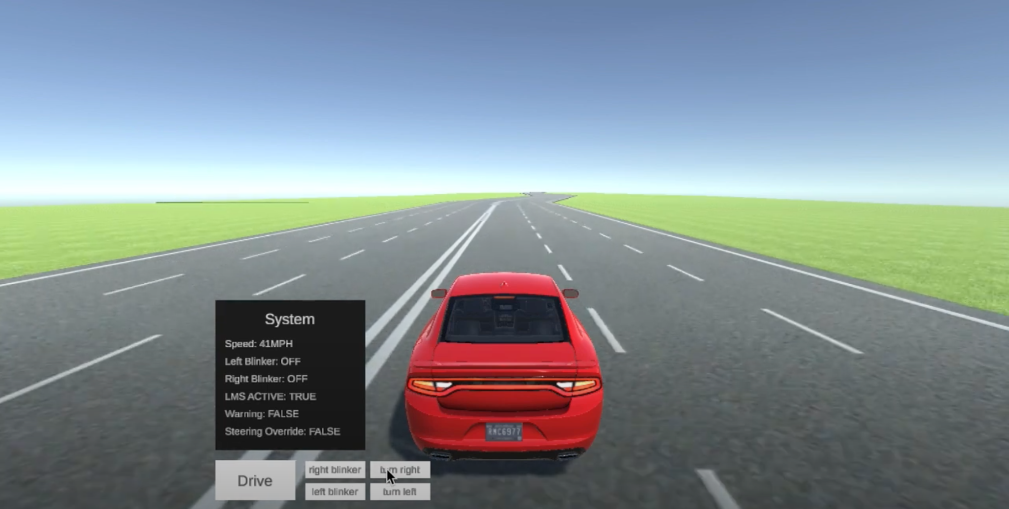

Figure 10: Scenario 1 Active State

As the car turns to the right to exit the lane with no turn signal, The LKS instructs the LCS to recenter the car which is done over the next 3 seconds as shown in Figure 11.

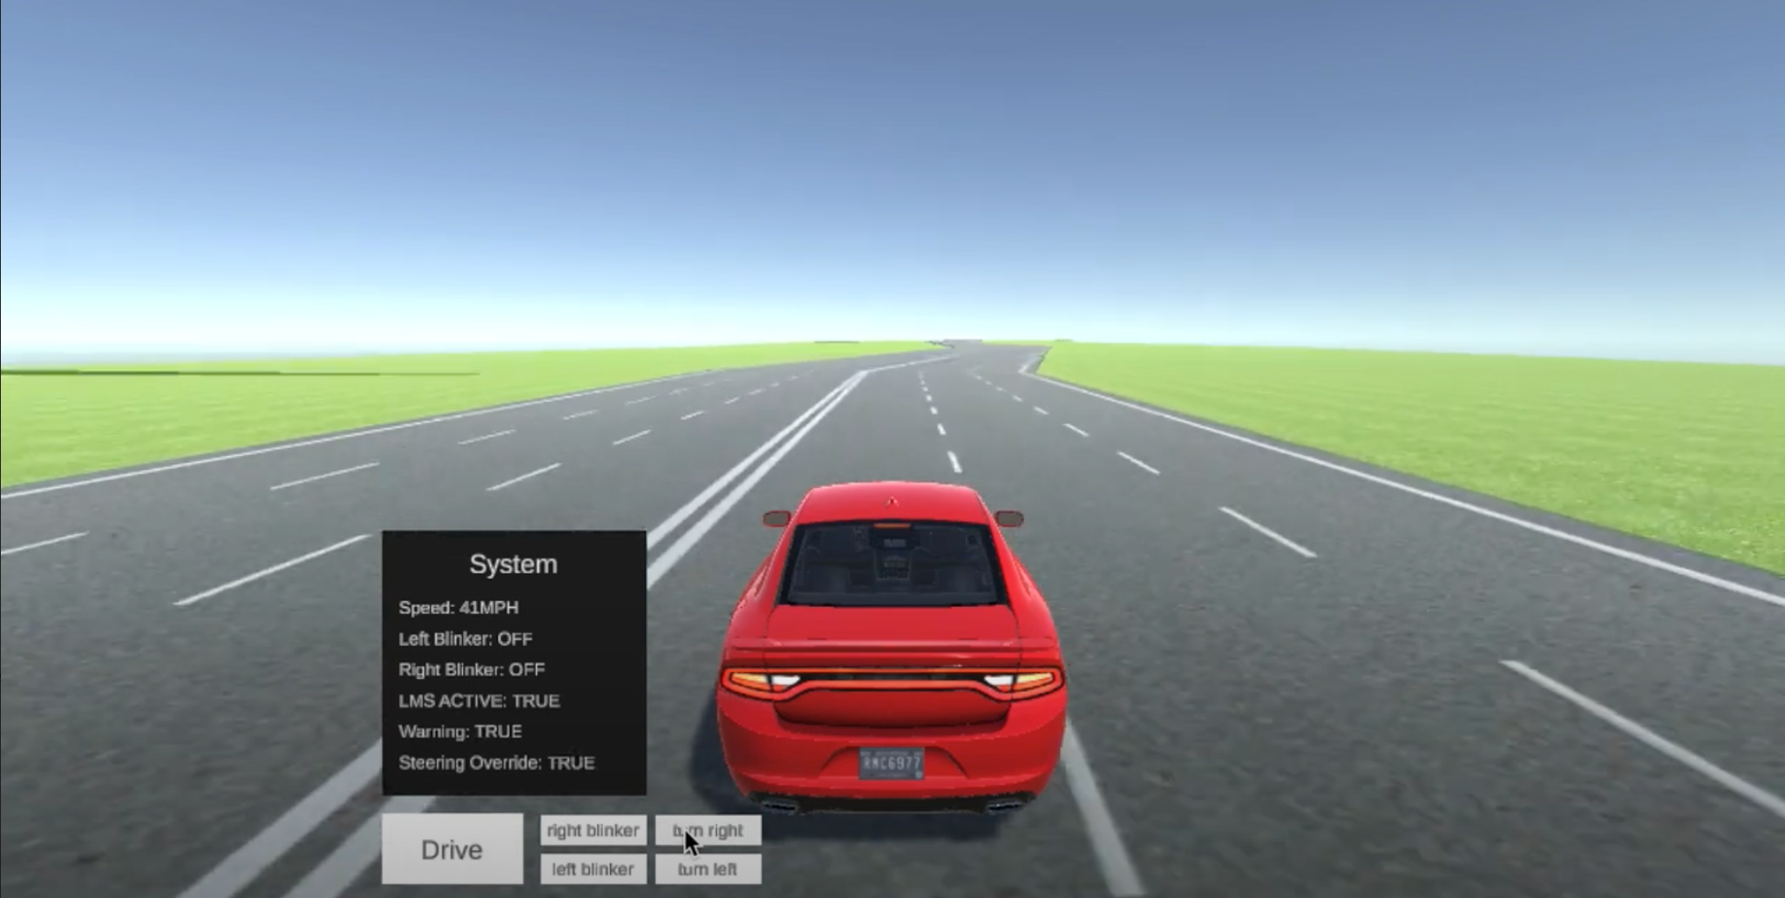

Figure 11: Scenario 1 State 2

The car then turns to the right to exit the lane with no turn signal, The LKS instructs the LCS to recenter the car which is done over the next 3 seconds as shown in Figure 12.

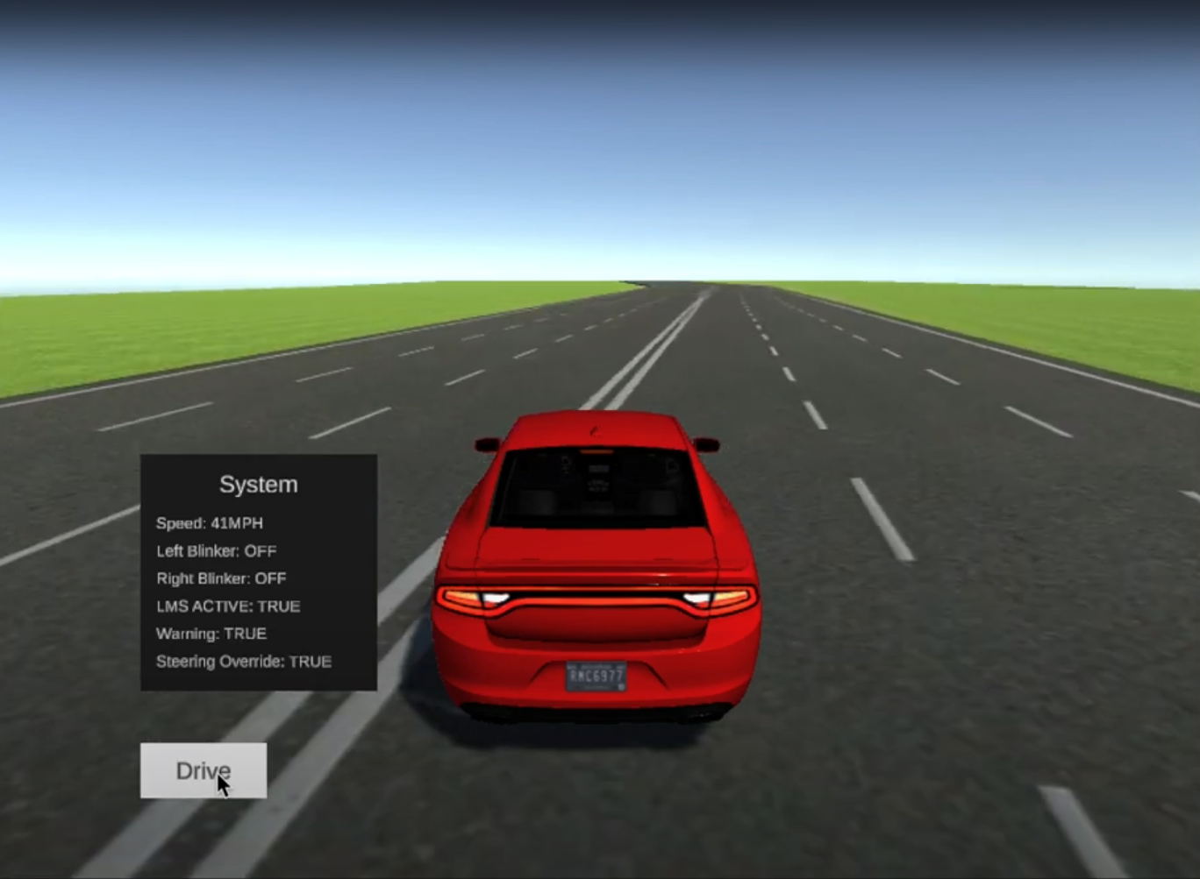

Figure 12: Scenario 1 State 3

The user then uses the right turn signal, and turns right after to change lanes without activating LKS and LCS, as shown in Figure 13.

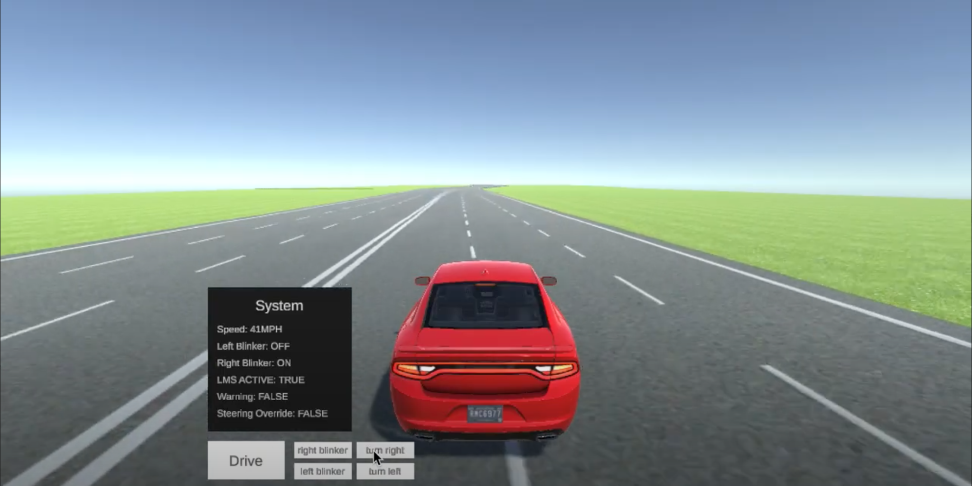

Figure 13: Scenario 1 State 4

The user then uses the left turn signal, and turns left after to change lanes without activating LKS and LCS, as shown in Figure 14.

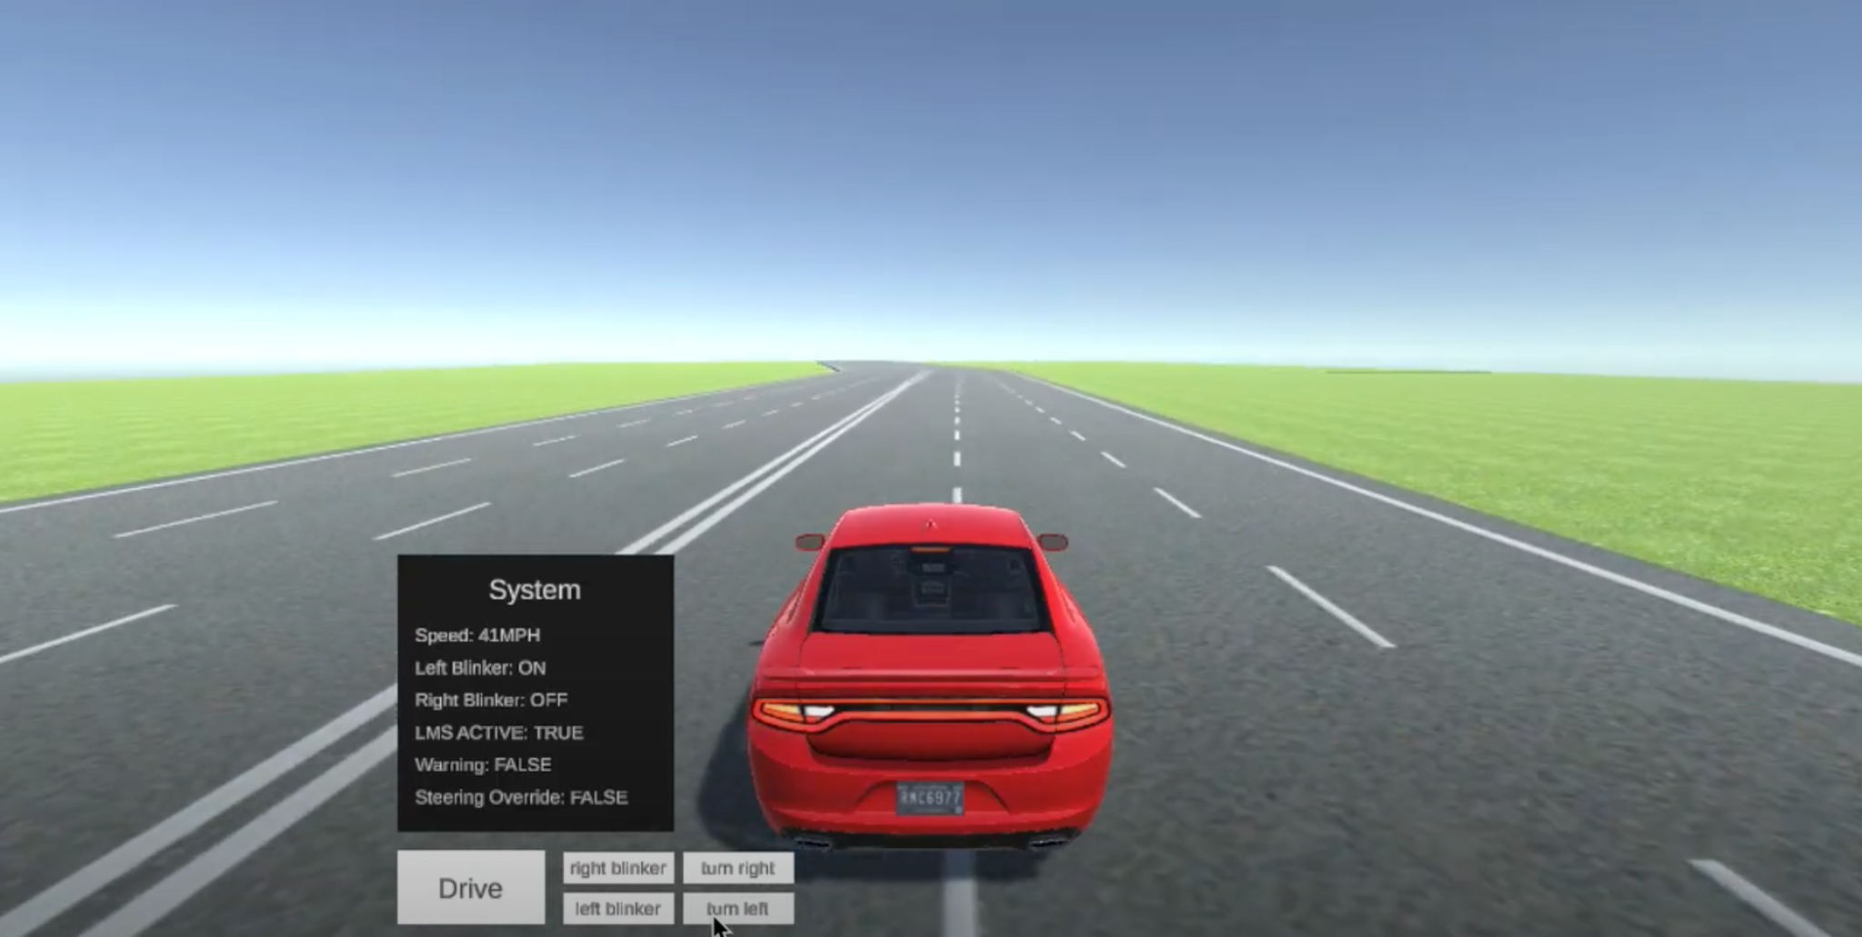

Figure 14: Scenario 1 State 5

This scenario is meant to demonstrate the gradual nature of the LMS’s correction as well as how the LDWS, LKS, and LCS function together. It showcases the hard limits of the LKS as 35 mph.

1. **References**

[1] I. Berriel, Z. Joyce, T. Lance, B. Gibbons, and M. Monticcilo, “Lane Management System,” *SWE-LMS2*. [Online]. Available: https://www.cse.msu.edu/~berrieli/. [Accessed: 18-Nov-2022].

[2] A. Agrawal, “Lane Management System”. [Online]. Accessible through Dr. Betty H.C. Cheng

[3] “The steering model - center for design research.” [Online]. Available: http://www-cdr.stanford.edu/dynamic/bywire/steering. [Accessed: 04-Dec-2022].

1. **Point of Contact**

For further information regarding this document and project, please contact **Prof. Betty H.C. Cheng** at Michigan State University (chengb at msu.edu). All materials in this document have been sanitized for proprietary data. The students and the instructor gratefully acknowledge the participation of our industrial collaborators.